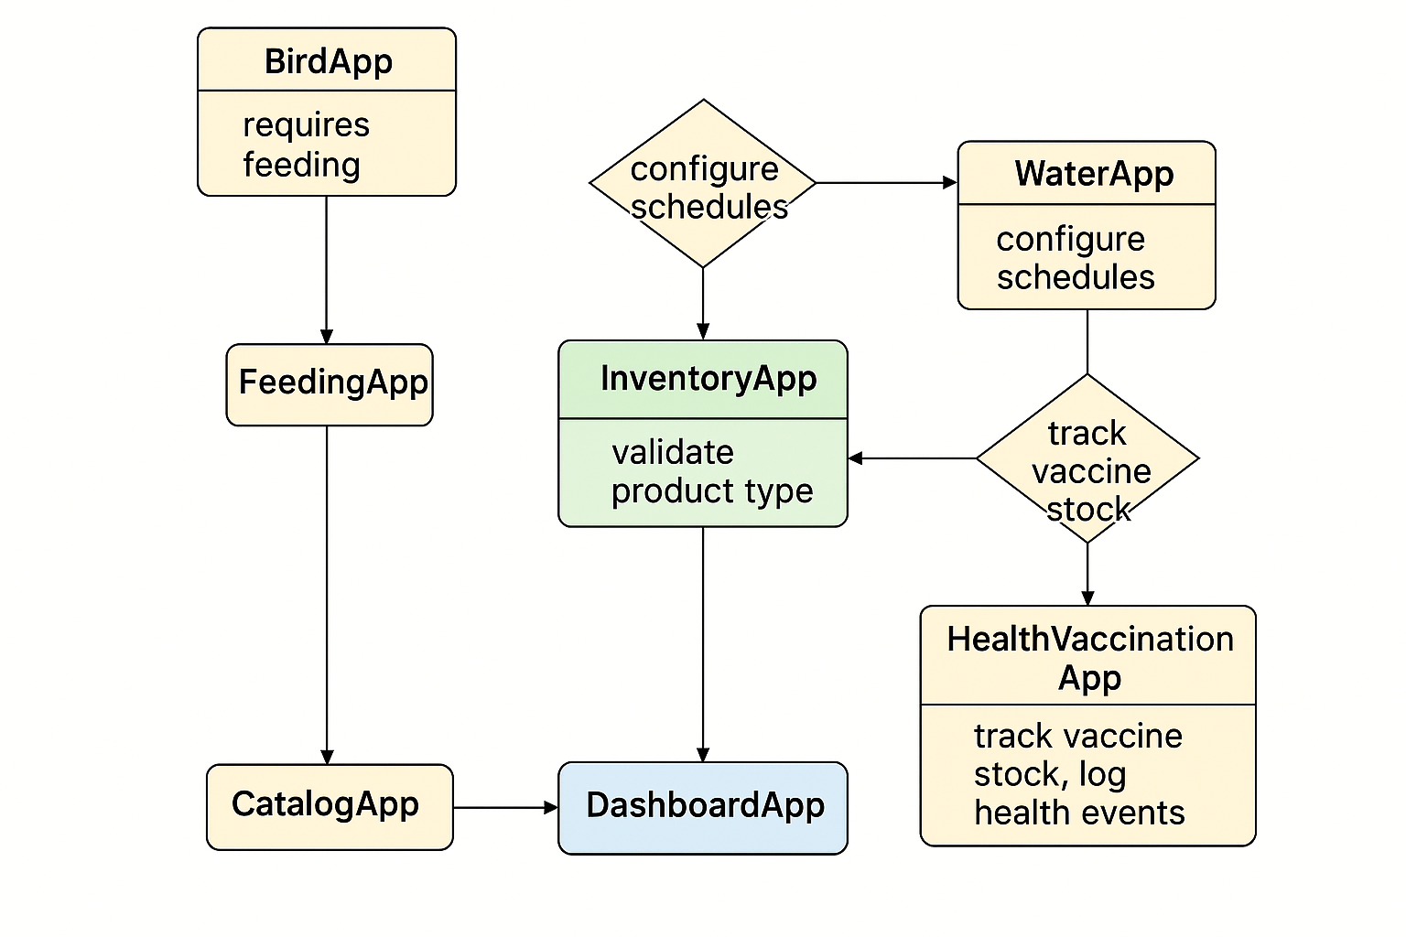

Absolutely, Djuma! Let's walk through your project architecture in detail so you fully understand how everything fits together.

**🧠 Project Overview**

Your system is a **modular, scalable poultry farm management platform** that integrates:

* **Operations** (daily farm activities)
* **Commerce & Inventory** (products and stock)
* **Infrastructure & Control** (physical layout and user roles)
* **Analytics & Reporting** (metrics and insights)
* **Admin & Configuration** (settings and alerts)

It supports **web, mobile, API**, and eventually **IoT integration**.

**🧩 Module Breakdown**

**1. Operations Module**

Apps: BirdApp, FeedingApp, WaterApp, CleaningApp, HealthVaccinationApp

**Purpose**: Manage daily activities for poultry flocks.

**Key Functions**:

* Feeding and watering schedules
* Health checks and vaccinations
* Cleaning routines
* Egg and meat production tracking

**Integration**:

* Uses products from CatalogApp
* Deducts stock from InventoryApp
* Logs metrics to DashboardApp
* Sends alerts via NotificationApp

**2. Commerce & Inventory Module**

Apps: CatalogApp, InventoryApp (in cartapp)

**Purpose**: Manage products and stock levels.

**Key Functions**:

* Define product categories (e.g., feed, vaccines, eggs)
* Track inventory movements
* Register production outputs
* Validate stock before operations

**Integration**:

* Linked to Operations for consumption
* Linked to Analytics for reporting
* Alerts sent via NotificationApp

**3. Infrastructure & Control Module**

Apps: FarmApp, HousesApp, FlocksApp, SectorApp, AccountApp

**Purpose**: Define the physical and logical structure of the farm.

**Key Functions**:

* Configure farm layout and housing
* Assign flocks to houses and sectors
* Manage user roles and access

**Integration**:

* BirdApp uses flock and housing data
* AccountApp controls permissions across modules

**4. Analytics & Reporting Module**

Apps: DashboardApp, ReportApp

**Purpose**: Provide insights and historical data.

**Key Functions**:

* Visualize feed, water, health, and production metrics
* Generate reports for operations and inventory
* Track trends and performance

**Integration**:

* Receives logs from Operations
* Uses data from InventoryApp and CatalogApp

**5. Admin & Configuration Module**

Apps: SettingsApp, NotificationApp

**Purpose**: Configure system behavior and send alerts.

**Key Functions**:

* Define operational thresholds and schedules
* Trigger alerts for low stock, missed operations, health issues
* Manage system-wide settings

**Integration**:

* Alerts triggered by Operations, Inventory, and Analytics
* Settings used by all modules

**🔄 Data Flow Example: Feeding a Flock**

1. BirdApp identifies flock and feed requirement.
2. FeedingApp checks feed stock via InventoryApp.
3. InventoryApp deducts feed quantity.
4. DashboardApp logs feed usage.
5. NotificationApp alerts if stock is low.

**🌐 API Layer**

Each app exposes RESTful endpoints. Example:

* POST /flocks/{id}/feed/ → triggers feeding
* GET /inventory/ → checks stock
* POST /notifications/ → sends alerts
* GET /metrics/feed/ → shows feed usage

**📦 Architecture Benefits**

* **Modular**: Easy to maintain and scale
* **Decoupled**: Each app handles its own logic
* **Extensible**: Ready for mobile, API, and IoT
* **Traceable**: Logs and metrics for every action
* **Automated**: Alerts and reports reduce manual work

Would you like this documented in a PDF or Markdown file? Or should I help you generate a README or technical spec for developers?